20BCE1837

EX No. 8

Date: 23.9.2022

AIM: To execute a PHP website

Procedure:

1. Type the JavaScript functions and save in a .js file.

2. Link the .js file to the .html file.

3. Open the .html file inside a web browser.

CODE:

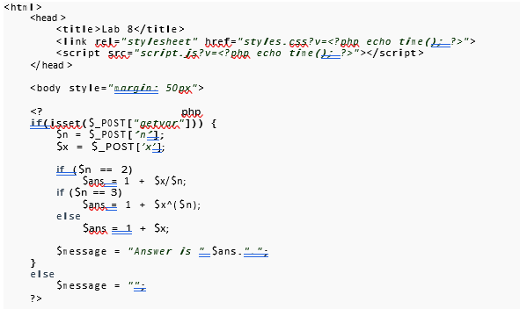

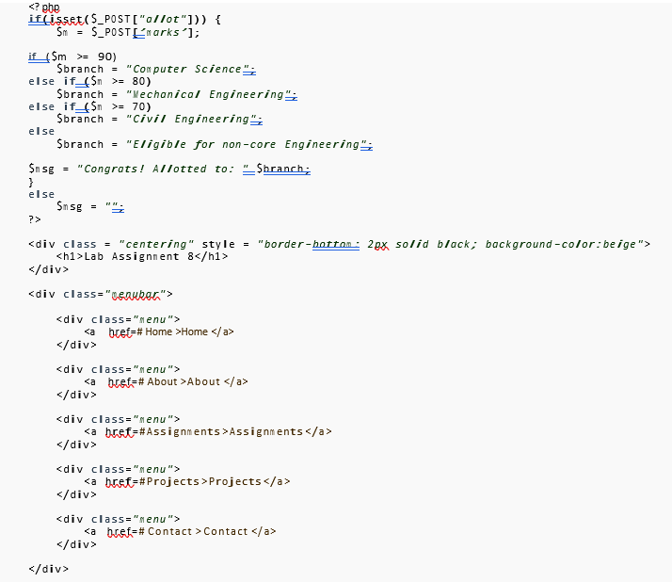

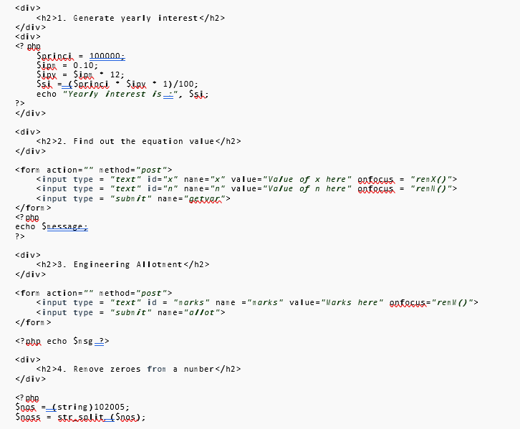

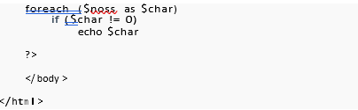

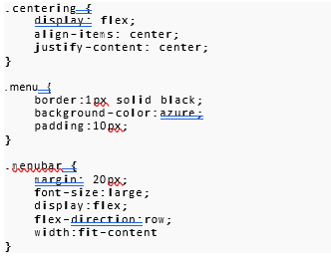

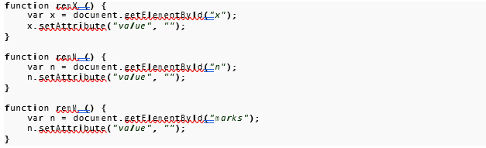

OUTPUT:

QUESTION 1:

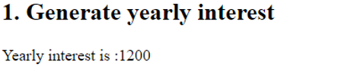



QUESTION 2:

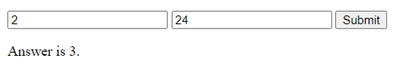

QUESTION 3:

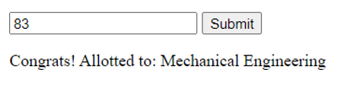

QUESTION 4:



RESULTS: Thus PHP was successfully implemented